Omega-3

What it is:
Omega-3 is an essential fatty acid that you need to get through food or supplementation; it cannot be made by your body. Healthy levels of it are 8-12% (measured as the amount of it found in the membrane of red blood cells). Low levels are below 4%. There is some research that has found that a level of 4% had people suffer a 5 year decrease in life expectancy compared to those with an 8% level. Smokers with an 8% level had the same life expectancy as non-smokers with a 4% level (Science Daily, “Higher levels of omega-3 acids in the blood increases life expectancy by almost 5 years” 7/22/2021, based on over 2,200 people age 65 and older and studied for 11 years on average). “A 1% increase in this substance in the blood is associated with a change in mortality risk similar to that of quitting smoking.”

What it does:

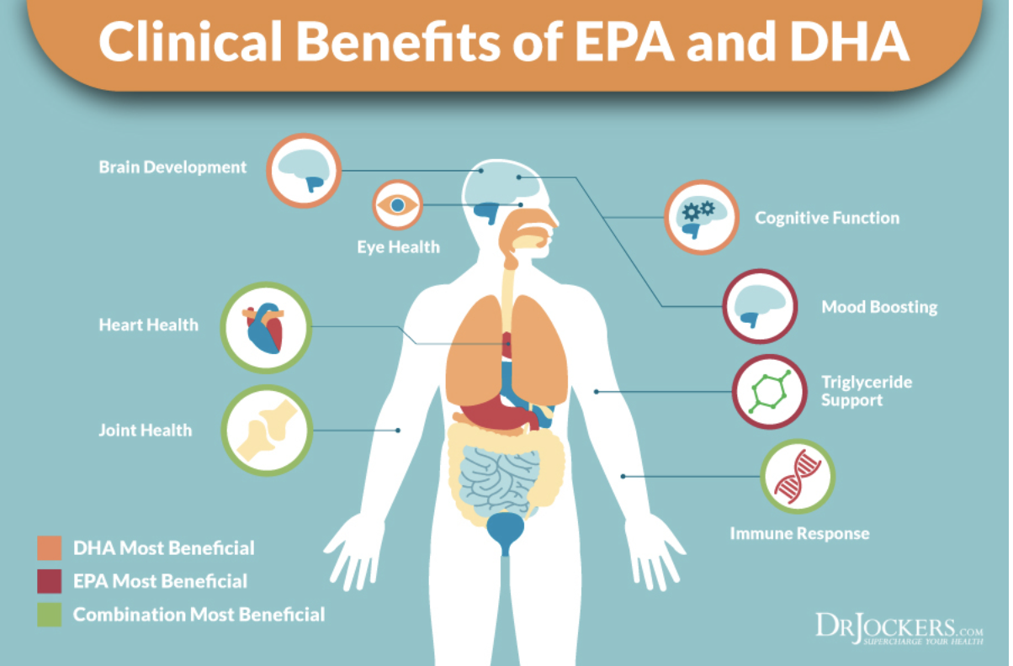

- DHA constitutes 90% of the omega3 found in the brain; EPA is more for heart function.
- it can support the immune system by reducing inflammation.
- it can help reduce triglyceride levels and slightly raise HDL (‘good’) cholesterol (both beneficial to heart health), may thin the blood, reduce homocysteine levels and blood pressure. Omega 3’s (DHA + EPA) are said to be more effective for lowering blood pressure than other lifestyle interventions such as increasing physical activity and restricting alcohol and sodium. The decrease is modest, running about 2-5 points off systolic and diastolic numbers using about 3-5 g/day of omega-3 which is a lot. There is enough evidence for its effect on b/p that the FDA allows a ‘qualified’ health claim which means that there is a known link of omega-3 to b/p reduction. But there has to be qualifiers about the evidence being inconsistent and inconclusive. There is no reliable evidence that fish oil supplements prevent heart disease in healthy people who are not at risk for heart disease. Nor is there research support for using such supplements to prevent heart attacks in people who have heart disease unless they have recently had a heart attack, such as through the VITAL trial (Vitamin D and omega-3) that looked at 25,000 people over five years. What VITAL did find is that these nutrients can reduce the risk of autoimmune disease such as lupus, rheumatoid arthritis, polymyalgia rheumatica, and psoriasis (BMJ, “Vitamin D and marine omega 3 fatty acid supplementation and incident autoimmune disease: VITAL randomized controlled trial” Jill Hahn et al, Jan. 2022).
- however, one study (Journal of Clinical Lipidology, “Erythrocyte long-chain omega-3 fatty acid levels are inversely associated with mortality and with incident cardiovascular disease: the Framingham Heart Study,” William Harris, et al, 2/24/2018) took 2,500 people roughly split evenly between women and men, who are among the children of the Framingham Heart study, ages 66-73. Results of it found that omega-3 levels are a better predictor of risk for death than cholesterol levels. Death rates were about 33% lower looking at the lowest vs. highest omega-3 levels. Moreover, higher omega-3 levels were associated with reduced risk of cardiovascular disease along with all causes of death measured over the following seven years.
- similar findings of the above were found in the Women’s Health Initiative Memory Study (Journal of Clinical Lipidology, Jan-Feb. 2017, William Harris et al). It followed 6,501 women ages 65-80 for about fifteen years. Higher omega-3 levels were associated with lower all-causes of death. Those with the highest levels of omega-3 (above 8%) had a 22% reduced risk of death vs. those with the lowest levels (below 4%).
- there is also research (Neurology, “Association of red blood cell omega-3 fatty acids with MRI markers and cognitive function in midlife” Claudia Satizabal et al, 12/6/22) that looked at 2,183 dementia- and stroke free participants (mean age of 46) and found that higher omega-3 levels were related to better brain structure and cognitive function in middle-aged adults. There was also a significant association between higher omega-3 levels and the hippocampus (the key area for memory) being larger in volume, along with better abstract reasoning.
- there is also research that higher DHA levels help with global cognition being benefitted from vitamin B supplementation, while those with lower DHA levels did not benefit from the vitamins folic acid (400 mcg) and B-12 (500 mcg) daily over two years. (European Journal of Nutrition, “DHA status influences effects of B-vitamin supplementation on cognitive aging: a post-hoc analysis of the B-proof trial” Annick P.M. van Soest et al, June 2022).
- a meta-analysis of 48 longitudinal studies involving over 103,000 people found a roughly 20% decrease of all-cause dementia or cognitive decline with those who had higher omega-3 intake, and especially for DHA. For every additional 100 mg/day of DHA or EPA there was an associated 8-8.9% lower risk of cognitive decline. (American Journal of Clinical Nutrition, “The relationship of omega-3 fatty acids with dementia and cognitive decline: evidence from prospective cohort studies of supplementation, dietary intake, and blood markers” Bao-Zhen Wei at el, June 2023).
- fish oil supplementation may help people with heart failure who have reduced left ventricular function.
- there is limited evidence that fish oil can modestly improve insulin sensitivity
- it can help prevent depression and anxiety, although not all research done on this agrees because of different doses that have been used. What is said to be the world’s largest meta-analysis on nutrient supplements looked at major depression (World Psychiatry, 9/9/2019, Joseph Firth et al) and involved 10,951 people. It was found that omega-3 was of the most benefit when used with high EPA formulas (at least 50% EPA, with an average dose of 1422 mg/day of EPA, and other research suggests 60% or more EPA is still better). Another national study (NHANES, 2011-2012) found that with higher EPA rates moderately severe to severe depression was cut by 70%, and the association remained present after adjusting for age, sex, race/ethnicity, education, marital status, poverty to income ratio, and smoking status. There also has been research done on kids age 13-18. It found lower rates of major depression with higher levels of omega-3. And, with a higher ratio of omega 6:omega 3 was associated with higher rates of major depression too. (Journal of Affective Disorders, “Association of n-3 polyunsaturated fatty acid status and intake with pediatric major depressive disorder in Swiss adolescents: a case-control study” Ester Osuna et al, Oct. 2023). Another study (JAMA Network Open, “Association of use of omega-3 polyunsaturated fatty acids with changes in severity of anxiety symptoms - a systematic review and meta-analysis’ Kuan-Pin Su et al, 2018) looked at 19 trials involving 2,240 people from eleven countries. Their main finding was that omega-3s (using an average dose of about 1,600 mg of omega-3/day) were associated with a significant reduction in anxiety symptoms compared to controls.
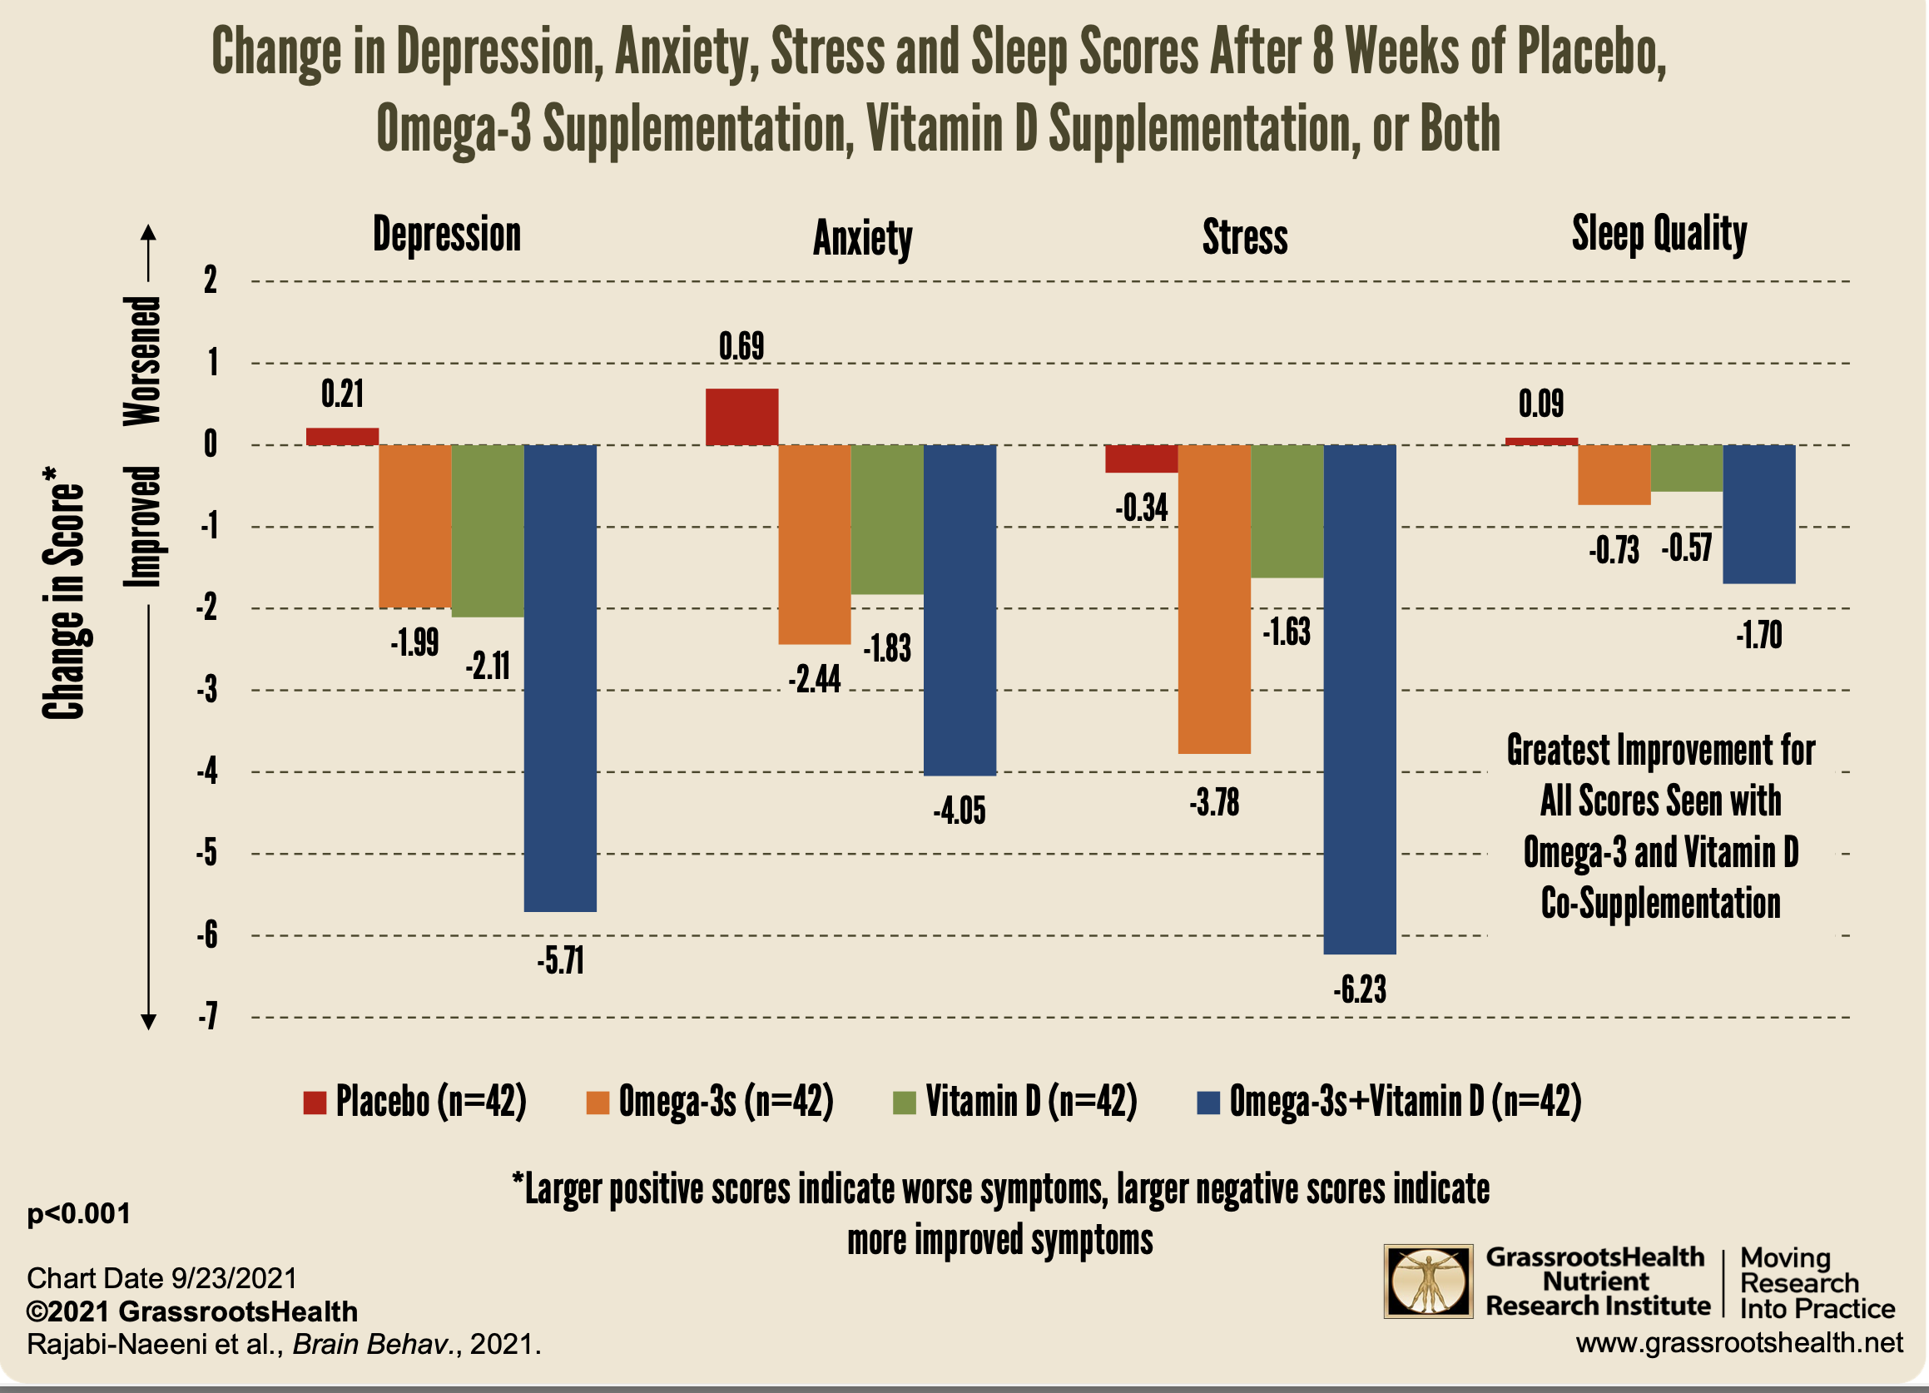

- Another study looked at supplementing for 8 weeks with
- a placebo group
- omega-3 at 2,000 mg/day and placebo vitamin
- vitamin D 50K IU every 2 weeks and placebo omega-3
- those doses of omega-3 and vitamin D

As can be seen use of both omega-3 and vitamin D had the largest positive benefit on depression, anxiety, stress and sleep. The study was done on 168 women with pre-diabetes and low vitamin D, ages 15-50, with equal numbers in each group. (Brain and Behavior, “Effect of omega-3 and vitamin D co-supplementation on psychological distress in reproductive-aged women and pre-diabetes and hypovitaminosis D: a randomized controlled trial” Masoumeh Rajabi-Naeeni et al, Sept. 2021).

- One Norwegian study found that omega-3 levels around 5% reduces the risk of post-partum depression, and up near 8% there is an even greater reduction. Other research found that expecting mothers with low omega-3 levels at week 28 had a higher risk of postpartum depression vs. those with higher omega-3 in their blood. It can also be potentially helpful for maintaining normal mood during pregnancy. It may also help with the depressive phase of bipolar disorder. There was also some research that it may help kids with ADHD, with high dose EPA formulas better although evidence is conflicting.
- there has been some research on omega-3 and kids being depressed. One study from 2012 was done on 150 adolescents who were admitted to a hospital for depression vs. healthy matched controls and an association was found to lower omega-3 levels in those admitted. A Swiss study done in 2023 looked at 95 kids ages 13-17 who were diagnosed with major depressive disorder and 95 healthy matched controls. Results were that higher omega-3 levels were associated with lower odds of depression, along with a higher omega-6:omega-3 ration also associated with greater odds of depression. (Journal of Affective Disorders, “Associations of n-3 polyunsaturated fatty acid status and intake with a pediatric major depressive disorder in Swiss adolescents: a case-controlled study” Ester Osuna et al, Oct. 2023).
- there was research done on military veterans involving 1,600 people, and those who committed suicide had significantly lower levels of DHA (below 1.75%) than those who did not. Only those with the higher levels of DHA, at 6% or above, were at lower risk for suicide.
- omega-3 can help increase the activity of BDNF (brain derived neurotrophic factor) that has been called ‘Miracle-Gro for the brain’ which helps grow new brain cells and improves memory.
- anxiety was modestly reduced especially when the EPA & DHA dose was 2,000 mg or more per day and the EPA/DHA ratio was less than 60%.
- there is mixed evidence for it helping migraines. One study that came out in the British Medical Journal in 2021 (“Dietary alteration of n-3 and n-6 fatty acids for headache reduction in adults with migraine: randomized controlled trial” by Christopher Ramsden et al) looked at omega-3 and omega-6 levels in 182 migraine sufferers, with an average age of 38, and who had migraines 5-20 days/month. They were divided into 3 groups of roughly equal size. One got a high omega-3 diet (EPA and DHA of 1.5 g/day). One group had a high omega-3 and low omega-6 (the same 1.5 g/day with linoleic acid decreased to 1.8% or less of calories). And a control diet where omega-3s were less than 150 mg/day, with linoleic acid around 7%. At the beginning of the study participants had an average of 16.3 headache days per month, and 5.4 hours of headaches/day. After 16 weeks those on the higher omega-3 diets had significantly decreased and severity of migraines compared to the control group. At the end of the study those on the control diet had 4.9 hours of headache/day, 3.6 hours for the high omega-3, and 3.2 hours for the high omega-3 and low omega-6. The low omega-6 group had 4 fewer days of headaches than the control group, and 2 fewer headache days than the just high omega-3. group.
- it can help benefit eye health. DHA is a large component of the retina, and there is a strong connection between omega-3 and risk of macular degeneration. It may also help with dry eye including that found with contacts being worn.
- according to FORCE (fatty acids & outcomes research consortium) involving over 42,000 people from around the world and followed for an average of 16 years those with a higher EPA + DHA level (at the 90th percentile, about 7.6% for the omega3’s) had a 13% lower risk for death vs. those down at the 10th percentile (around 3.5% reading for the omegas). Statistically significant reductions were found in death from cardiovascular disease, cancer and all other causes combined (using 90th vs. 10th percentiles of EPA+DHA, with reductions of 15%, 11% and 13%, respectively).
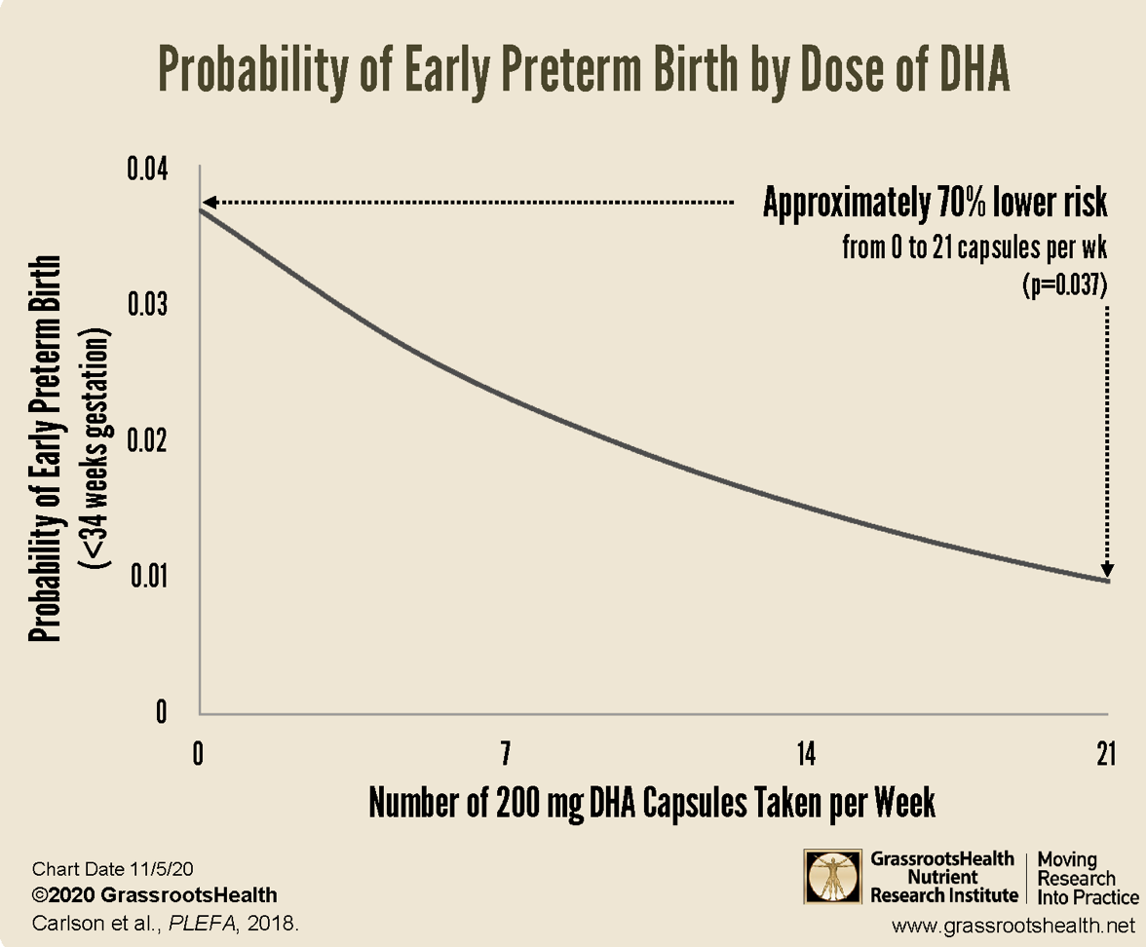
- Omega-3 and DHA are important during pregnancy and early life. It can lead to a higher IQ in the child, better social skills, fewer behavioral problems, and decreased risk of developmental delay, ADHD, autism, and cerebral palsy. One study found that a higher intake of EPA and DHA led to roughly a 70% decrease in early preterm birth, 85% for very low birth weight, and 60% for low birth weight (Prostaglandins, Leukotrienes & Essential Fatty Acids, “Dose-response relationship between DHA intake and lower rate of early preterm birth, low birth weight and very low birth weight” Susan Carlson et al, 11/1/2018).
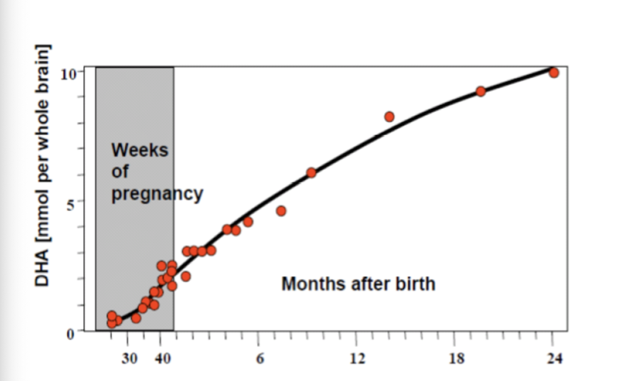
The graph to the left reflects showing how much DHA accumulates during pregnancy and the first two years of life. Babies brains double in the size during the first year of life.
From World Revision of Nutrition and Dietetics, M. Martinez, 1991 (66:87-102).

It can help with sleep quality. Low levels of DHA have been associated with lower levels of melatonin, the sleep hormone. One study on kids ages 7-9 found that 600 mg/day of DHA led to an extra hour of sleep. Another study found that in teens those with the highest levels of DHA slept 32 minutes longer when given supplementation for a week.
- There was another study looking at the combination of omega-3 and vitamin D, using 42 women in each of four groups (placebo only, omega-3 + placebo vitamin D, vitamin D plus omega-3 placebo, genuine omega-3 + vitamin D). They were also pre-diabetic and had low D levels. It was done over eight weeks. All 3 groups with genuine supplements benefitted, but the completely placebo group did not. The biggest benefit was in the fourth group, with both vitamin D and omega-3 being genuine as to reducing anxiety, depression, and stress, while improving sleep quality. (Brain & Behavior, “Effect of omega-3 and vitamin D co-supplementation on psychological distress in reproductive-aged women with pre-diabetes and hypovitaminosis D: a randomized controlled trial” M. Rajaba-Naeeni, et al, 9/2/2021).
- one study found that those having a high level of omega-3 had 44% less risk of cognitive impairment, relative to age-related mental decline and Alzheimer’s (Dementia & Geriatric Cognitive Disorders, 10/5/2016, Karoline Lukaschek, et al), looking at 720 people ages 68-92. Another study (the Framingham Offspring Cohort), involving almost 1500 dementia-free people age 65 and up found that those who were in the highest quintile (with DHA above 6.1%) had a 49% lower rate of Alzheimer’s compared to those in the lowest quintile (DHA <3.8%). Rising from the lowest to the highest quintile was predicted to provide an additional 4.7 years of life free from Alzheimer’s.
- it may help with rheumatoid arthritis especially in the early stages, as to impacting pain but not joint function. It might be beneficial to use a product with 50% more EPA than DHA, but an ideal dose could not be determined by research
- there is some research to suggest it may help with menstrual cramps, inflammatory bowel disease (ulcerative colitis and Crohn’s), lupus, and IgA nephropathy.
- eating fish is associated with a lower risk of recurrence and death from breast cancer.
- one study found that it can help with postmenopausal symptoms such as sweating, hot flashes, sleep problems, depressed mood and anxiety, but not joint discomfort, bladder problems or vaginal dryness. Other research in 1,111 postmenopausal women through the Women’s Health Initiative Memory Study (WHIMS) and found that EPA + DHA levels were correlated with a larger total brain volume. The hippocampal volume (the area of the brain that is the center of memory) was also larger.
- there is also research that low omega-3 levels are associated with increased risk of gestational diabetes, and pre-term birth. A meta-analysis of 5,980 women (all with single babies) and not on any other treatment for the prevention of preterm birth were on omega-3’s. Intake of it was associated with a 17-58% reduction of preterm birth. Levels of 6% or higher during pregnancy is advised by some.
- there was research (Cambridge University Press, “Dietary and serum omega-3 polyunsaturated fatty acids and PCOS: a matched case-control study” Ling Lu et al, 8/10/21) that took 325 women with PCOS and 325 controls without it (matched for age, BMI, age at menarche, fasting glucose, insulin, total energy intake, smoking, and alcohol status). Higher dietary intake of omega-3 was associated with a 39% decreased risk of PCOS.
- it can help with recovery from exercise as well as increase endurance. It relaxes blood vessels through production of nitric oxide which then allows more oxygenated blood to flow to muscles, improving endurance and reducing fatigue. It also has anti-inflammatory properties to help reduce muscle damage after workouts, meaning it can reduce soreness so a quicker recovery results.
- a high intake of omega-3 has been linked with improved semen quality and reproductive hormone levels in men. Plus there is a reduced risk of ovulatory problems and improved fertility in women.
There has been concern that fish oil supplements may be contaminated with mercury because it accumulates in fish. However, mercury is typically not found in supplements due to the purification process.

Sources of omega-3 from food include (mg per 100 g/100 calories):
- anchovies (2,100/1,000)
- bluefish
- carp (900/600)
- catfish
- halibut (700/500)
- herring (2,200/1,100)
- lake trout (1,200/800)
- mackerel (1,400/500)
- oyster (1,500/900)
- pompano
- salmon (farmed salmon may contain more PCB’s than other sources; 2,600/1,400)
- sardines (1,500/700)
- striped sea bass
- white tuna (albacore; may contain high levels of mercury)
- tuna bluefin (1,700/1,100)
- whitefish
- walnuts (ALA: 9,100/1,400)
- Brazil nuts
- Brussels sprouts (ALA: 200/500)
- cashews
- cauliflower
- chia seeds (ALA: 17,800/3,700)
- flax seeds (ALA: 23,000/4,300)
- hemp seeds
- hazelnuts
- kale
- pecans
- pumpkin seeds
- spinach
- tofu
- winter squash

Foods like seeds and nuts have ALA than can be converted into omega-3, but it is not an efficient process and only a small percentage becomes DHA & EPA. Vegetarians and vegans are especially poor in making the conversion. There also needs to be adequate levels of vitamins B3 (niacin), B6 (pyridoxine), magnesium and zinc for the conversion process to work well. Cigarette smoke, heavy metals (e.g. lead) or a lot of alcohol can also interfere with the conversion process. Therefore, supplementation or eating fish is the best way to get the omega-3’s.

Canned salmon generally provided more EPA and DHA than canned tuna along with lower levels of mercury and arsenic.

As to whether farmed or wild caught salmon is better, it depends mostly on what the farmed salmon are fed which can include fish oil or vegetable oil. Wild salmon provides more vitamin D, and contamination tends to be lower in the wild.

Possible symptoms of deficiency
- skin irritation, flaky, sensitive, red, dryness
- depression
- dry eyes
- joint pain and stiffness
- poor concentration
- mood related changes such as irritability, anxiety, mood swings
- frequent urination
- excessive ear wax
- weak, easily broken nails

Who is at risk of deficiency?
Almost everyone is at suboptimal levels in this country. There was a national study done (NHANES, the National Health & Nutritional Examination Survey, 2003-2004) involving a representative sample of 1,386 Americans over the age of 20 that found 95.7% had less than optimal levels of omega-3s. Hispanics were most likely to have low omega-3s.

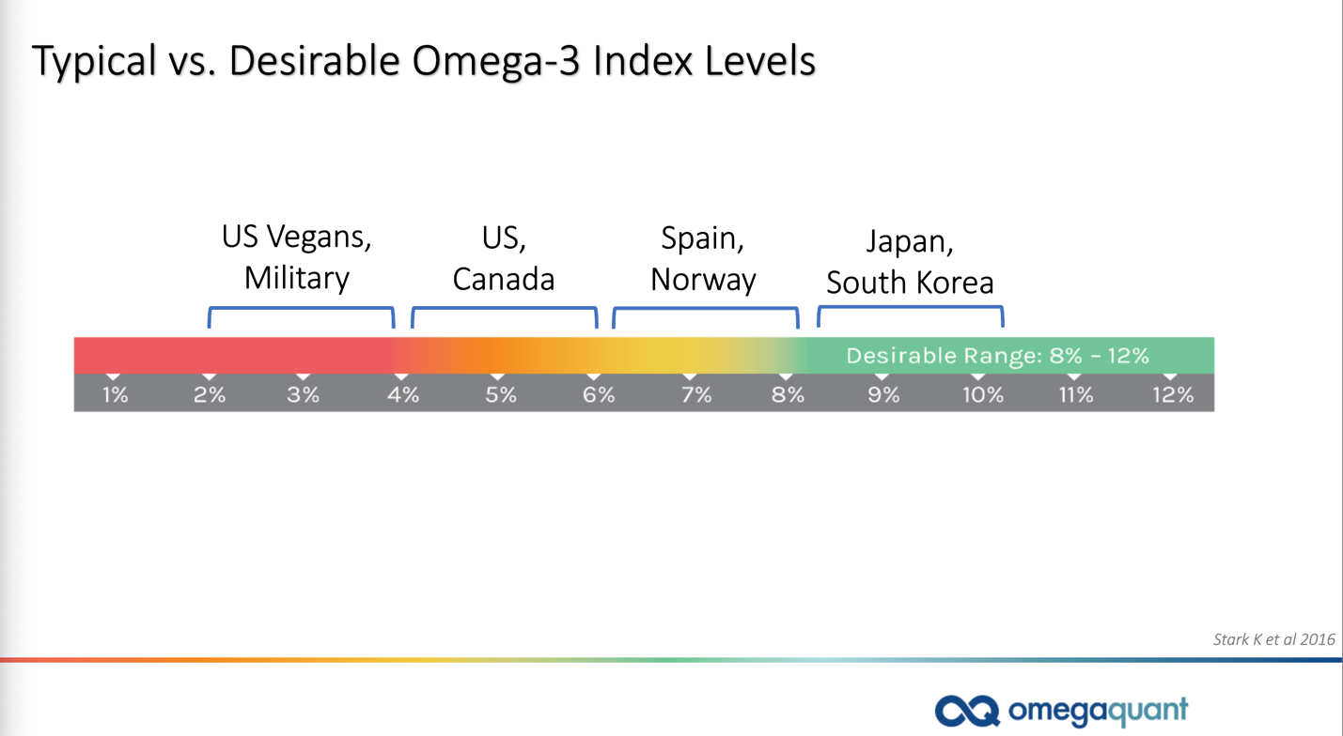
The graphic to the left shows the general state of Americans having at best marginal levels of omega-3s vs. the Japanese who are heavy fish eaters and are the longest-lived people on the planet.

There is a diminishing return for levels over 12%.

Being heavier in weight increases the dosage needs. One study (grassrootshealth.net) found that 1,480 mg/day of EPA+DHA was needed for those who weighed 150 pounds or more, vs. 1,040 mg/day for those under 150 pounds. Other research on 2,482 people by grassrootshealth.net found that only 14% of those under 30 years old reached an omega-3 level of at least 8% compared to 23% of those who were 70 years or older.

Some research has found that kids with an omega-3 index above 6% is ideal for optimal cognitive development, but different kids may need different amounts. (Nutrients, “Effect of omega-3long chain polyunsaturated fatty acids (n-3 LCPUFA) supplementation on cognition in children and adolescents: a systematic literature review with a focus on n-3 LCPUFA blood values and dose of DHA and EPA” Inge van der Wurff et al, Oct. 2020).

Dosage:
There is no recommended dosage for EPA and DHA, but the American Heart Association recommends at least two servings of fish a week for a total of 6-8 ounces. Fish species with lower levels of poisons like mercury is advised. Shark, swordfish, albacore tuna, and King mackerel are known to have high levels of mercury. Pregnant and nursing women should not eat these more poisoned fish at all. The Food & Nutrition Board of the US Institute of Medicine says that an adequate omega-3 intake is 1600 mg/day for men, and 1100 mg for women. For kids what is considered an adequate intake are:

 | Female | Male
0-12 months | 500 mg | 500 mg
1-3 years | 700 | 700
4-8 years | 900 | 900
9-13 years | 1000 | 1200
14-18 years | 1100 | 1600
Pregnant | 1400
Lactating | 1300
Some countries recommend 300-500 mg of a combination of these two essential oils, and this amount is roughly equal to the omega-3’s obtained from having fish twice a week. The FDA recommends no more than 2 grams/day from a dietary supplement, and 3 grams/day from food included. High doses may suppress the immune system. Fish oil especially above 3000 mg/day of DHA & EPA can have a blood thinning effect. Medical consultation is advised for those on blood thinners (e.g. Coumadin, heparin) or those with hemophilia.

There was research done that found that how much of a boost one’s omega-3 level gets from taking 1,000 mg of EPA + DHA can vary widely, with results running from 5.7% to 10.2%. i.e. You need to re-test yourself to see where you end up.

Fish or fish oil supplements may interfere with chemotherapy, and it has been advised to avoid fish oil from a day before to a day after chemo.

There is some research suggesting doses that may be helpful for various conditions; such numbers are not set in concrete.

Condition | Possible dose to consider
Ulcerative colitis (maintaining remission) | 1000 mg twice/day of enteric coated EPA
Pregnant, nursing women (fish or supplements) | 100-200 mg/day
Reducing risk of very premature birth | 800 mg DHA, 100 mg EPA/day
Reducing risk of retinal disease (fish, not from supplements) | 200+ mg of EPA & DHA/day
Depression | 2,500 mg (1670 mg EPA, 830 mg DHA)/day for 8 weeks
Anxiety | 2085 mg EPA + 348 mg DHA/day
Stress | 1600 mg EPA + 1100 DHA/day
ADHD (in boys not already getting omega-3 from diet) | 650 mg EPA + 650 mg DHA/day
Strength training | 180 mg EPA + 120 mg DHA/twice a day
Acne | 1000 mg EPA + DHA/day
Migraine | 400 mg EPA + 350 mg DHA/twice a day along with meds (amitriptyline 10 mg)
Improvement .in working memory in healthy young adults; best results may take 6 months | 930 mg EPA + 750 mg DHA/day or  1160 mg DHA + 170 mg EPA
Epilepsy (for 10 weeks) | 1080 mg EPA + DHA/day
Mild cognitive impairment | 1550 mg DHA + 400 mg EPA/day, or:  1670 mg EPA + 160 mg DHA/day
Alzheimer’s (slowing the decline in ability to perform daily activities) | 650 mg EPA + 450 mg DHA in the morning  325 mg EPA + 225 mg DHA at lunch  600 mg alpha-lipoic acid in the morning helped slow the decline in cognitive functioning
Fish oil is best taken with a meal containing fat.

There is also research on a ‘threshold effect’ for omega-3 as to getting no benefit if a certain amount is not reached in the body. For kids the threshold is at 6% and below that level changes in cognition are not likely. Older adults without dementia who have an omega-3 level below about 5% are at increased risk of cognitive decline as well according to research and could benefit from such supplementation.

Omega-3 vs. omega-6:
The benefits of omega-3 have been offered above. Omega-6 is inflammatory, and large amounts of it are found in vegetable oils, and such oil consumption has greatly increased over time. Inflammation can impact diseases such as cardiovascular, diabetes, metabolic syndrome, IBS, macular degeneration, rheumatoid arthritis, asthma, cancer, and autoimmune diseases. One study found that replacing corn oil with olive and canola oil to get an omega 6:3 ratio of 4:1 led to a 70% decrease in total mortality. The omega 6:3 ratio varies in people, but some studies have found it up in the 15-50:1 level. The omega-6:3 ratio that is suggested is not definitive, but they tend to run from 4:1 - 1:1.

Some research (Biomedical Pharmacotherapeutics, “The importance of the ratio of omega-6/omega-3 essential fatty acids,” Oct. 2002, A. Simopoulos) found that a

- 2-3:1 ratio suppressed inflammation in rheumatoid arthritis patients
- 5:1 ratio helped with asthma, while a 10:1 ratio had adverse effects
- 2.5:1 reduced colorectal cancer cell proliferation while 4:1 did not

There was a study done on 68 people with rheumatoid arthritis (Rheumatology International, “Anti-inflammatory effects of low arachidonic acid diet and fish oil in patients with rheumatoid arthritis” Olaf Adam et al, Jan. 2003) that was done over 8 months. They were split into two equal sized groups and were either on a western diet or one with arachidonic acid intake below 90 mg/day. They were also given a placebo or fish oil capsules (30 mg per kg of body weight) for 3 months with a crossover design. Their findings included

- no improvement in the Western diet without the fish oil
- a 17% improvement in the Western diet with fish oil
- a 14% improvement with the anti-inflammatory diet
- a 31% improvement with the anti-inflammatory diet + fish oil.

Oil | Omega-6 content | Omega-3 content
Safflower | 75% | 0%
Sunflower | 65% | 0%
Corn | 54% | 0%
Cottonseed | 50% | 0%
Sesame | 42% | 0%
Peanut | 32% | 0%
Soybean | 51% | 7%
Canola | 20% | 9%
Walnut | 52% | 10%
Flaxseed | 10% | 57%
Fish | 0% | 100%
Omega-3 and omega-6 compete with each other. If you have more omega-3 there will be less omega-6 in tissues to produce inflammation. But the opposite also holds true: high levels of omega-6 reduces omega-3’s ability to have healthy benefits.

Omega-6 should not be viewed as all bad. They have a role in human health too. For instance, they are involved with inflammation which is part of the immune system. They also are involved with the making of hormones, blood clotting, and cell proliferation. They are also involved with maintaining bone health, promoting skin and hair growth, and repair muscle such as after exercise. The current problem is the imbalance that has been arisen between omega-6 and 3 in recent years.

Blood tests can determine the amount of omega-3 in red blood cell membranes. Values of 8-12% are associated with lower cardiovascular risk.

Higher doses of fish oil (1-4 g/day) may increase the risk of afib by 25% for those with a pre-existing heart disease according to some research.

There is also some research looking at the ratio between arachidonic acid (AA, an inflammatory chemical) and EPA (anti-inflammatory) as a biomarker for systemic inflammation. One study suggests an AA:EPA ratio of 1.5-3 as being best relative to optimal inflammation levels.

There is also some research at looking at supplementing omega-3 + vitamin D, which has found that ‘the whole is greater than the sum of the parts.’ When taken together there is the potential to significantly affect

- insulin resistance
- non-alcoholic fatty liver disease
- prediabetes
- type 2 diabetes associated with coronary heart disease
- gestational diabetes
- PCOS
- type 1 diabetes
- inflammatory bowel disease (IBD)
- autism spectrum disorder (one study called MARBLES found that higher levels of EPA+DHA in the second half of pregnancy led to a 40% reduction in the likelihood of having an autistic child. No difference was found for this being so in just the third trimester.

Interactions:
People with arrhythmias should proceed cautiously with a doctor’s advice with omega-3 use especially in the first 2-3 months of taking such a supplement. Omega-3 can also increase AST and ALT liver enzymes, and anyone with liver impairment should be cautious. Liver enzyme levels should be monitored periodically.

Some of the drugs that omega-3 can interact with (red indicates serious, blue moderate, black milder interactions) are shown below. The same problem arises with all of them, although one is potentially more severe. The warning for all of them is as follows:

It may increase the risk of bleeding although this is rare. If you experience unusual bleeding or bruising, or have signs such as dizziness, being lightheaded, have red or black tarry stools, are coughing or vomiting fresh blood or have dried blood that looks like coffee grounds, have a severe headache, or weakness you should contact your doctor.

- abciximab:
- alteplase
- anagrelide
- anisindione
- anistreplase
- antithrombin (recombinant)
- antithrombin III
- apixaban
- ardeparin
- argatroban
- aspirin
- betrixaban
- bivalirudin
- bromfenac:
- cangrelor
- caplacizumab
- cilostazol:
- clopidogrel
- dabigatran
- dalteparin
- danaparoid
- defibrotide
- desirudin
- dextran 1/higher/lower molecular weight
- diclofenac
- dicumarol
- diflunisal
- dipyridamole
- drotrecogin alfa
- edoxaban
- enoxaparin
- epoprostenol
- eptifibatide
- etodolac
- fedratinib
- fenoprofen
- flurbiprofen
- fondaparinux
- heparin
- ibrutinib: it can lead to a severe and potentially fatal hemorrhage. The warning offered for all the other drugs in this section applies.
- ibuprofen
- iloprost
- indomethacin
- ketoprofen
- ketorolac
- lepiriudin
- meclofenamate
- mefenamic acid
- meloxicam
- nabumetone
- naproxen
- oxaprozin
- pentoxifylline
- phenylbutazone
- piroxicam
- prasugrel
- reteplase
- rivaroxaban
- streptokinase
- sulfinpyrazone
- sulindac
- tenecteplase
- ticragrelor
- ticlopidine
- tinzaparin
- tirofiban
- tolmetin
- treprostinil
- urokinase
- vorapaxar
- warfarin

